Alerts

Using Alerts feature, employer can communicate messages to employees. The created alerts are displayed in employees Home Page under Alert section.

To create Alerts, Go To Configure menu > Alert

Select Branch from drop down list if the message to be sent to any particular branch or All to be sent to all employees irrespective of branch categorization.
Enter From date & To date
Enter the message in Message to be displayed text box
Click on ADD button to save the entered details.

Saved Alert message displays as per below screen shot

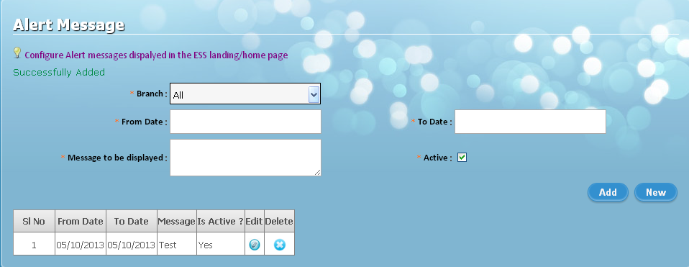

Note: This message will be active/displayed within that selected period, post completion of the given to date message will be automatically made inactive.

Created Alerts Messages will be shown in Employees login home page, as shown in below screen shot.

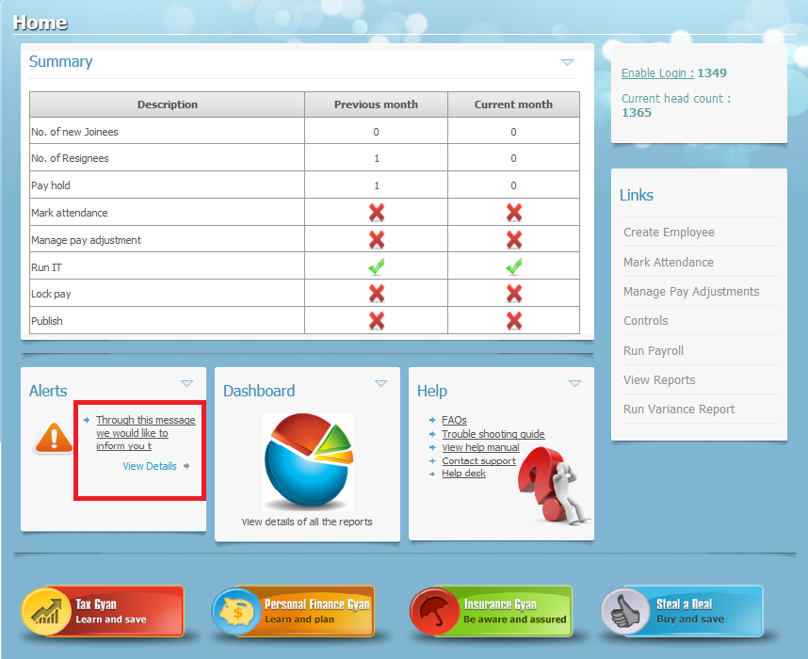

Click on View details to go to Alerts page to see the message in detail and other relevant messages, if any.



